**Vivekanand Education Society’s**

**Institute of Technology**

**(Affiliated to University of Mumbai, Approved by AICTE & Recognized by Govt. of Maharashtra)**

**Department of Information Technology**

AIDS - 2 Lab

Experiment - 6

Aim: To implement Fuzzy Membership Functions.

| Roll No. | 53 |
| --- | --- |
| Name | SAKSHI SANTOSH PATIL |
| Class | D20B |
| Subject | AIDS - 2 |
| Grade: |  |

**EXPERIMENT - 6**

**AIM:** To implement Fuzzy Membership Functions.

**THEORY**:

Fuzzy membership function is used to convert the crisp input provided to the fuzzy inference system. Fuzzy logic itself is not fuzzy, rather it deals with the fuzziness in the data. And this fuzziness in the data is best described by the fuzzy membership function. Fuzzy inference system is the core part of any fuzzy logic system.

Formally, a membership function for a fuzzy set A on the universe of discourse X is defined as µA: X → [0, 1], where each element of X is mapped to a value between 0 and 1. This value, called membership value or degree of membership, quantifies the grade of membership of the element in X to the fuzzy set A. Here, X is the universal set and A is the fuzzy set derived from X.

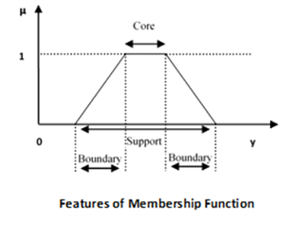

⦁ **Core:** For any fuzzy set A˜, the core of a membership function is that region of the universe that is characterized by full membership in the set. Hence, core consists of all those elements y of the universe of information such that

⦁ **Support:** For any fuzzy set A˜, the support of a membership function is the region of the universe that is characterized by a nonzero membership in the set. Hence core consists of all those elements y of the universe of information such that

⦁ **Boundary:** For any fuzzy set A˜, the boundary of a membership function is the region of the universe that is characterized by a nonzero but incomplete membership in the set. Hence, core consists of all those elements y of the universe of information such that

Following are a few important points relating to the membership function:

⦁ Membership functions characterize fuzziness (all the information in a fuzzy set), whether the elements in fuzzy sets are discrete or continuous.

⦁ Membership functions can be defined as a technique to solve practical problems by experience rather than knowledge.

⦁ Membership functions are represented by graphical forms.

⦁ Rules for defining fuzziness are fuzzy too.

**IMPLEMENTATION**:

* Installing important libraries

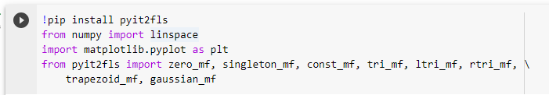

* In the following code, we will see various fuzzy membership functions. These functions are mathematically very simple. Fuzzy logic is meant to deal with the fuzziness, so use of complex membership functions would not add much precision in final output.

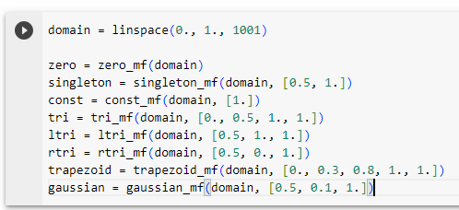

* **Constant membership function** assigns membership value 1 to all values of x, and All Zero membership function assigns value 0 to the rest of all.

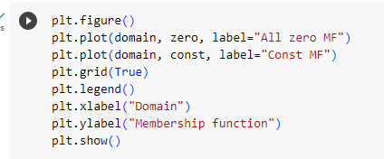

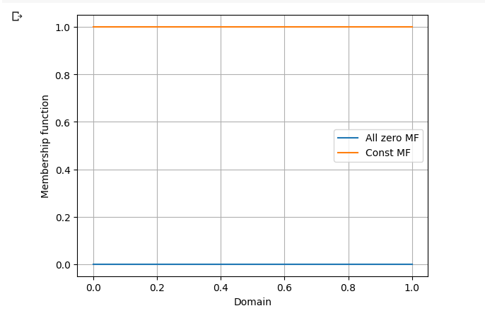

* **Singleton membership function** assigns membership value 1 to a particular value of x, and assigns value 0 to rest of all.

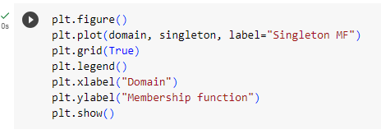

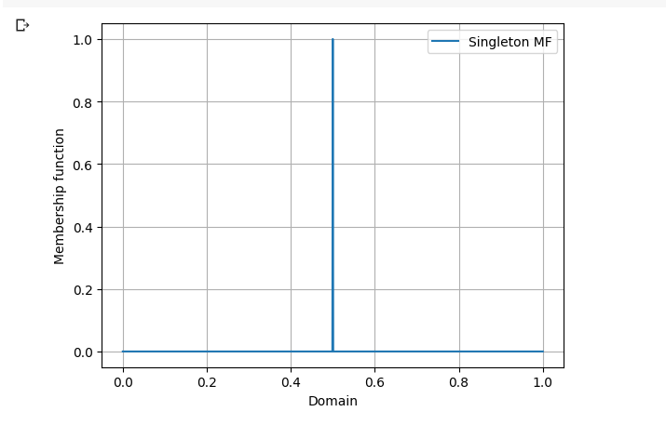

* The **triangular membership function** which fuzzifies the input can be defined by three parameters a, b and c, where c defines the base and b defines the height of the triangle.

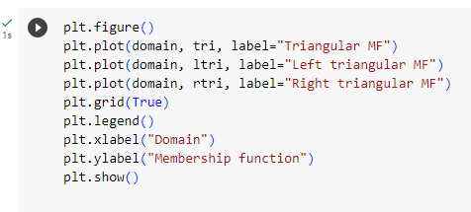

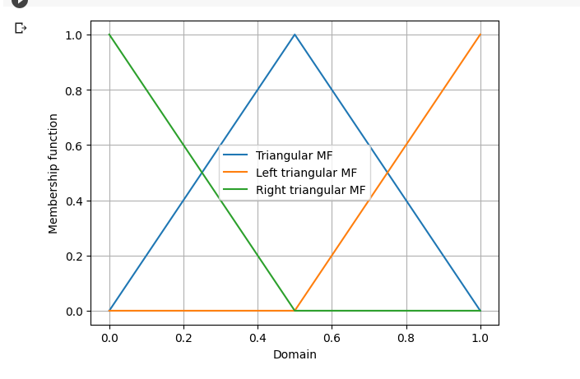

* **Gaussian MF** is specified by two parameters {m, σ} and in this function, m represents the mean / center of the gaussian curve and σ represents the spread of the curve.

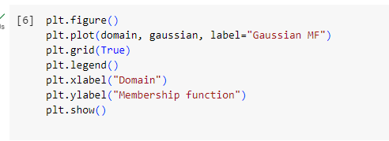

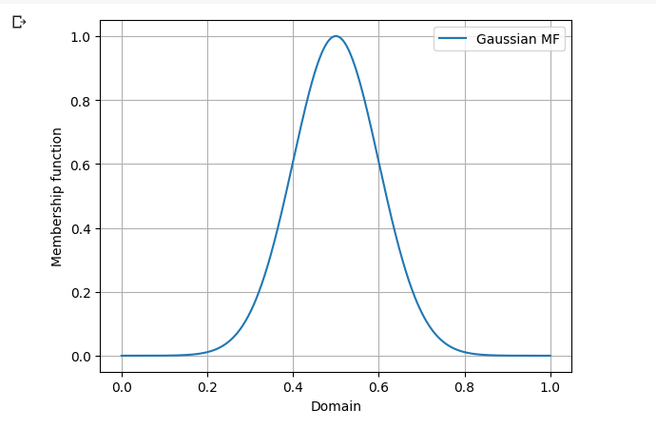

**CONCLUSION:**

Fuzzy membership function is used to convert the crisp input provided to the fuzzy inference system. Thus we successfully performed different fuzzy membership functions.